**COMP1111 Custom Reports – Class Notes**

Here’s part of the completed report using Medical Clinic database:

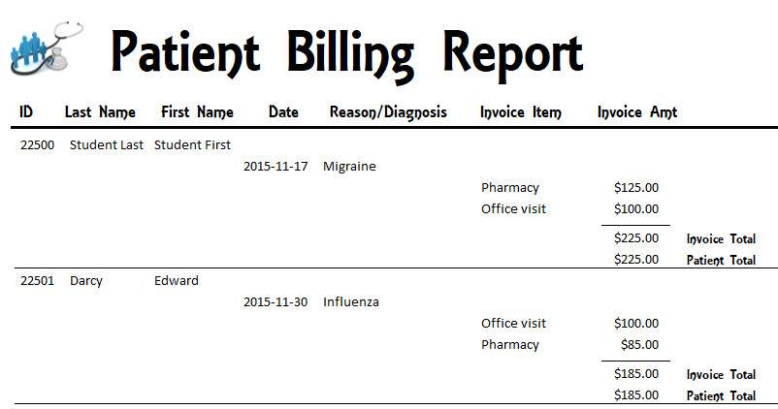

… and further on down in same report showing one patient with 3 invoices (billings):

Duplicate values hidden

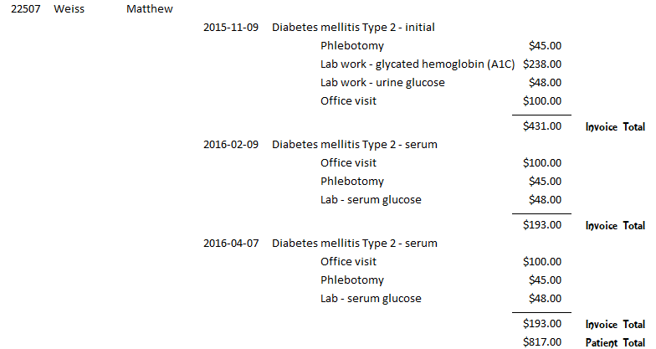

**Step 1**: Create a query to use as report’s data

Create/Query Design

tblPatient: PatientID, Last Name, First Name

tblVisit: VisitDate, Reason

tblInvoiceItem: invoiceItem

tblBilling: invoiceAmt sort by🡺 PatientID

Save as **QueryForReport**

**Look at the query’s result and compare to the screenshot on page 1**

**Step 2**: Create the report

Create / Report Wizard

Choose QueryForReport, add all fields, select all defaults

Save as **Billing Report**

**It will look like this to start!**

The ##### indicates the text box needs to be widened in Layout or Design view to display contents

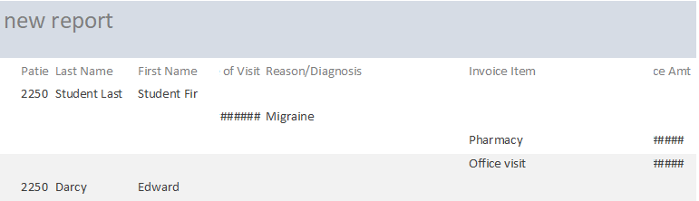

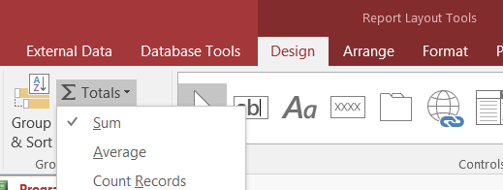**To add totals:**

Layout view/click the InvoiceAmt control, click Totals Σ button in the Design tab/Sum

This will automatically create =SUM

(see screen shot bottom of page 3)

You will need to add labels to say “Invoice Total” and “Patient Total”

**To remove borders from controls:**

Select controls with border/RT-click any control, Properties, Borderstyle: Transparent

**Lines:**

Line control, hold Shift key when dragging to keep a straight line

Change width (Borderwidth property) /colour in line’s Property Sheet

**Conditional Formatting**

This is done to highlight some of the values – e.g. display all values that are less than $1000 in bold, red font color. You can also format text as well – e.g. if city is Kingston, display in bold, italics.

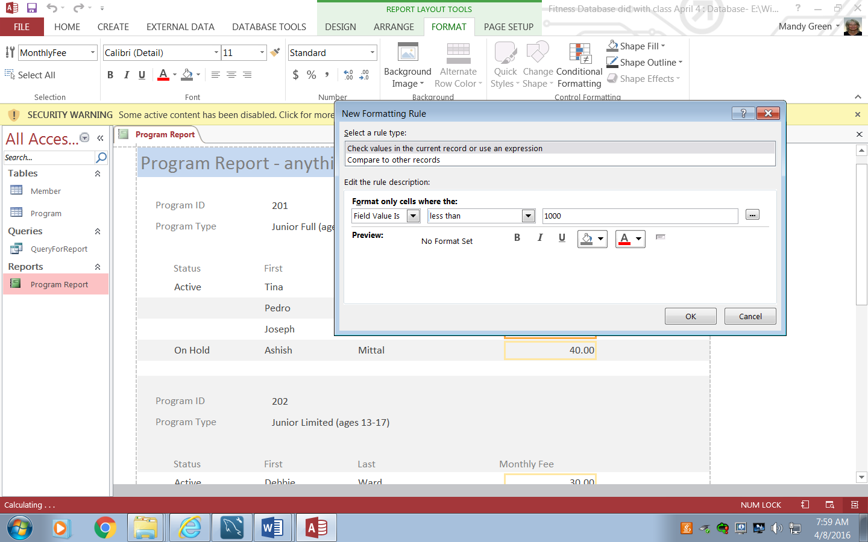

In Layout or Design view, click on the field you wish to format, then click Format tab /Conditional Formatting, New Rule

This is the completed report in **Design View:**